MICROBIOLOGY MAJOR INFORMATION

Department of Microbiology

105 Biological Sciences Building

484 West 12th Avenue; Columbus, OH 43210

Tel: (614) 292-2301; Fax: (614) 292-8120

http://microbiology.osu.edu

Department Chair:  Dr. Kurt Fredrick  105 Bio Sci Bldg.  614-292-2301  Fredrick.5@osu.edu | Honors Advisor:  Dr. Madhura Pradhan  372 Bio Sci Bldg.  614-292-1196  Pradhan.2@osu.edu
Coordinating Advisor:  Matt DeBlieck  320 Bio Sci. Bldg.  614-292-6961 (ASC Advising phone #)  DeBlieck.2@osu.edu | Coordinator of Undergraduate Research:  Dr. Natividad Ruiz  264 Aronoff Bldg.  614-292-3426  Ruiz.82@osu.edu

Required Prerequisites* to the Major

Credits from these courses do not count toward the 30 hours required to complete the Major; however, some are prerequisites for required major courses. All Prerequisites must be completed prior to graduation with a minimum grade of “D”.

Biology 1113**, 1114** 8-10 hr.
Mathematics 1156⁺ or 1151⁺ 5 hr.
Statistics 1450**, 2450**, or 2480** 3 hr.
Chemistry 1210⁺, 1220⁺ 10 hr.
Chemistry 2510, 2520, 2540 10 hr.
Physics 1200⁺ or 1250 5 hr.

* Honors courses can substitute where available. Alternative course sequences can be used with prior advisor approval.
** Either version of these courses will be accepted (.01 or .02). Please note that Biology 1113 & 1114 will vary in credit hours depending on the version (i.e. Bio 1113.01 & 1114.01 are 4 credits each; Bio 1113.02 & 1114.02 are 5 credits each).

+ Prerequisites for these courses include earning a “C-” or higher in a relevant math course.

Additional science courses may be required or suggested for pre-professional students.

Microbiology Major Courses—General Information
The Microbiology Major consists of a minimum of 30 semester hours. Required Core courses make up 21 of these 30 hours. All students must complete the six Core Courses and nine (9) hours of elective courses (outlined below). A minimum grade of "C-" in every major course is required.

Elective courses are divided into two groups: Group 1 and Group 2. Students must take at least three (3) hours of Group 1 courses and may take all nine (9) elective hours from Group 1. Students are not required to take any Group 2 courses but may have up to six (6) hours from this group count as elective hours. Students are encouraged to discuss with their microbiology major advisor any courses that are not listed in Group 2 that would be suitable to include in the Microbiology Major.

A total of three (3) semester hours graded S/U may be counted toward the Microbiology Major. These are usually earned through Individual Study, Undergraduate Research or Honors Research (Microbiology 4193, 4998, 4998H, 4999 or 4999H). Individual Study courses may be arranged by contacting any faculty member in the department prior to course enrollment. You may also discuss your research options with the Coordinator of Undergraduate Research.

Students must receive a C- or better in Microbiology courses to use them as prerequisites for other courses. Students must earn a grade of C- or higher for a course to transfer to Ohio State. The only exception to this is courses transferred from a public institution in Ohio since 2006. In these cases, credit for courses with grades of D and D+ will transfer to Ohio State. This rule cannot be appealed.

Microbiology Major Required Core Courses, 21 Hours

Department # | Credit Hours | Course Title (Semester taught) | Prerequisites*
Biochemistry 4511 | 4 | Introduction to Biological Chemistry (Au, Sp, Su) | Chemistry 2310 or 2510; One semester of Biological Sciences
Microbiology 4100‡ | 5 | General Microbiology  (Au, Sp) | Biology 1113(.01 or .02);  Chemistry 1220
Microbiology 4110 | 3 | Microbial Pathogenesis and Immunobiology (Au, Sp) | Microbiology 4100 (C- or better) ‡
Microbiology 4120 | 3 | Microbial Physiology and Diversity (Au, Sp) | Microbiology 4100 (C- or better) ‡; Biochem 4511 or concurrently
Microbiology 4130 | 3 | Microbial Genetics (Au, Sp) | Microbiology 4100 (C- or better) ‡ or Molecular Genetics 4500 or 4606
Microbiology 4140 | 3 | Molecular Microbiology Laboratory (Au, Sp) | Microbiology 4100; Microbiology 4130 or concurrently (C- or better ‡)
* Honors courses can substitute where available.
‡ Non-majors who earn an A or an A- in Microbiology 4000(.01 or .02) can request to enter the microbiology major without taking Microbiology 4100. Students who enter the major via Microbiology 4000 must take 10h of electives to complete the 30 credit hours required for the major.

Microbiology Major Electives, 9‡ Hours
Students must select a minimum of 9‡ credits of major electives from the coursework below. At least 3 of the 9‡ credits must specifically come from Group 1 courses and there is no minimum requirement for Group 2 courses.

ELECTIVE COURSES, GROUP 1: Take 3-9 hr. from this group‡
Micro. Course No. | Credit  Hours | Course Title  (Semester taught) | Prerequisites
2000* | 1.5  Graded S/U | Introduction to  MicrOHbIOlogy Research (Au) | Biology 1113
2100* | 3 | Wild Yeast: From Isolation to Fermentation (Au, Sp, Su) | Biology 1110 or 1113;  Chemistry 1110, 1210, or 1610
3704* | 4 | HIV: From Microbiology to Macrohistory (Sp) | English 1110.xx. Not open to students with credit for History 3704
4145 | 3 | Introduction to Industrial Microbiology and Bioprocessing Laboratory (Au, Sp) | Microbiology 4100 or 4000.01/.02, or permission from instructor
4150 | 3 | Immunobiology Laboratory (Sp) | Microbiology 4110 or 5122, or permission from instructor
4193 | 1-3  Graded S/U | Individual Studies (Au, Sp, Su) | Permission of instructor. Maximum of 3 credit hours can be counted toward the major
4591S | 1  Graded S/U | DNA Fingerprinting; Service learning course (Sp) | Molecular Genetics 4500 or 4606
5122 | 3 | Immunobiology (Au) | C- or better in either Microbiology 4000 or 4110
5129 | 3 | Cellular and Molecular Biology of Pathogenic Eukaryotes (Sp) | Microbiology 4100 (C- or better)
5147 | 3 | Eukaryotic Pathogens (Au) | Microbiology 4100 (C- or better)
5149 | 3 | Introductory Virology (Sp) | Microbiology 4100 (C- or better)
5155 | 3 | Environmental Microbiology (Au) | Microbiology 4000 or 4100 (C- or better)
5161 | 3 | Bioinformatics and Molecular Microbiology (Au) | Recommended: Microbiology 4130, or Molecular Genetics 4500, or Biochemistry 4511
5270 | 3 | Microbial Natural Products: Discovery, Biosynthesis,& Antibiotic Activity (Irregular Offerings) | C- or better in either  Microbiology 4120 or Biochemistry 5614
5536 | 3 | Food Microbiology Lecture (Au) | C- or better in either Microbiology 4000 or 4100; Not open to students with credit for FDSCTE 5536
5546 | 3 | Food Microbiology Laboratory (Sp) | Microbiology 5536; Not open to students with credit for FDSCTE 5436
Undergraduate Research**
4998/4998H  4999/4999H | 1-5  Graded S/U | Undergraduate Research in Microbiology (Au, Sp, Su)  Undergraduate Research in Microbiology—Thesis (Au, Sp, Su) | Permission of instructor. Maximum of 3 credit hours for courses using the S/U grading basis can be counted toward the Major.  Thesis requires a minimum of 4 cumulative credit hours and final thesis examination. Check with your advisor for details.
* Only three credit hours of 2000 or 3000 level microbiology elective courses can count towards the BS-major. Students must meet with an advisor to have coursework pre-approved for Study at a Foreign Institution or a Domestic Study Tour. Credit (S/U) may be applicable to the Microbiology Major.
** If you plan to do 4998 in a lab outside of Microbiology you must talk with your major advisor PRIOR to registering to confirm it will count towards the Major.
‡ Non-majors who earn an A or an A- in Microbiology 4000(.01 or .02) can request to enter the microbiology major without taking Microbiology 4100. Students who enter the major via Microbiology 4000 must take 10h of electives to complete the 30 credit hours required for the major.

ELECTIVE COURSES, GROUP 2: Take 0-6 hr. from this group‡
Course No. | Credit Hours | Course Title (Semester taught) | Prerequisites
Biology 2200* | 1 | Genome Biology (Sp) | Biology 1113 with SEA Phages Lab
Biochemistry 5621 | 4 | Introduction to Biological Chemistry Laboratory (Au, Sp) | C- or better in Biochemistry 4511 or 5613
CBE 5765 | 3 | Principles of Biochemical Engineering (Irregular Offerings) | CBE 2523 or 3610
EARTHSC 5160 | 3 | Geomicrobiology (Sp) | Sr or Grad standing in School of Earth Sciences, Department of Microbiology, Department of Civil, Environmental, and Geodetic Engineering, or School of Environment and Natural Resources.
ENVENG 5120 | 3 | Bioremediation of Groundwater and Soil (Irregular Offerings) | A class in Microbiology (4100 recommended)
ENR 5263 | 3 | Biology of Soil Ecosystems (Irregular Offerings) | ENR 3000
Molecular Genetics 4500 | 3 | General Genetics (Au, Sp, Su) | Biology 1101, 1113, or 1113H; 3 additional semester credit hours in Biological Sciences
Molecular Genetics 4501 | 1 | General Genetics Laboratory  (Au, Sp, Su) | Molecular Genetics 4500 or concurrently
Molecular Genetics 4606 | 4 | Molecular Genetics (Au, Sp) | Biology 1113 (Recommended), 1114, or Chem 1220
Molecular Genetics 5800 | 2 | Organelle Biology  (Irregular Offerings) | Molecular Genetics 4500 or 4606
Plant Pathology 5010 | 2 | Phytobacteriology (Au) | Plant Pathology 3001 and 3002
Plant Pathology 5020 | 2 | Introduction to Plant Virology (Au) | Plant Pathology 3001 and 3002;  At least one course in Biochemistry, Microbiology, or Molecular Genetics
Plant Pathology 5040 | 3 | Science of Fungi: Mycology (Au) | A course in the Biological sciences  (Biology 1114 recommended)
* Only three credit hours of 2000 or 3000 level microbiology elective courses can count towards the BS-major.
‡ Non-majors who earn an A or an A- in Microbiology 4000(.01 or .02) can request to enter the microbiology major without taking Microbiology 4100. Students who enter the major via Microbiology 4000 must take 10h of electives to complete the 30 credit hours required for the major.

Microbiology Faculty (https://microbiology.osu.edu/directory)
Name | Scientific Focus | @osu.edu
Stephen Abedon | Bacteriophage ecology; phage therapy (OSU-Mansfield) | abedon.1
Brian Ahmer | Detection of microbes and host environment by Salmonella | ahmer.1
Birgit Alber | Biochemistry of central carbon metabolism | alber.8
Amal Amer | Innate immunity against Legionella and Burkholderia | amer.13
Irina Artsimovitch | Regulation of transcription | artsimovitch.1
Prosper Boyaka | Mucosal Immunity | boyaka.1
Patrick Bradley | Human microbiome, computational biology, statistics, and machine learning | bradley.720
Tammy Bullwinkle | tRNA biology | bullwinkle.1
Steven Carlson | Microbial Physiology | carlson.271
Charles Daniels (Emeritus) | Molecular biology of the archaea; archaeal SNO-RNAs | daniels.7
Karen Dannemiller | Indoor Environmental Quality – environmental engineering and public health | dannemiller.70
Rajendar Deora | Molecular determinants of pathogenesis and biofilm development | deora.6
Purnima Dubey | Vaccines, Bordetella pertussis, cancer immunology | dubey.36
Kurt Fredrick | Mechanistic studies of protein biosynthesis | fredrick.5
Venkat Gopalan | Protein-aided RNA catalysis | gopalan.5
John Gunn | Salmonella and Francisella host-pathogen interactions | gunn.43
Tina Henkin (Emeritus) | Transcription termination control in Gram positive bacteria; RNA structure/function | henkin.3
Igor Jouline | Computational biology, evolutionary genomics, signal transduction | jouline.1
Kou-San Ju | Natural products; microbial metabolism; biocatalysis | ju.109
Joseph Krzycki | Biochemistry and molecular biology of methanogenic archaea | krzycki.1
Jesse Kwiek | HIV pathogenesis and public health | kwiek.2
Shan-Lu Liu | Host restriction to viral infection; innate immunity to viruses; viral oncogenesis | liu.6244
Karin Musier-Forsyth | RNA-protein interactions; retroviral RNA packaging; aminoacyl-tRNA synthetases; tRNA biology | musier-forsyth.1
Justin North | Microbial metabolism; Bio-fuels and bio-products | North.62
Steve Oghumu | Immunology | oghumu.1
Madhura Pradhan | Microbial pathogenesis and immunology | pradhan.2
Chad Rappleye | Molecular mechanisms of fungal virulence | rappleye.1
John Reeve (Emeritus) | Molecular biology of archaea; molecular adaptations to extreme environments | reeve.2
Virginia Rich | Global change microbiology; microbial meta-omics; Genes-to-Ecosystems inquiry | rich.270
Yasuko Rikihisa | Obligatory intracellular bacteria; Anaplasma, Ehrlichia, and Neorickettsia | rikihisa.1
Natividad Ruiz | Envelope biogenesis in Gram-negative bacteria | ruiz.82
Zakee Sabree | Insect microbe interactions; nutrient cycling; microbial evolution and ecology | sabree.8
Abhay Satoskar | Immune mechanisms | satoskar.2
Stephanie Seveau | Bacterial toxins and infectious diseases | seveau.1
Matthew Sullivan | Phage ecology, evolution, host interaction, and discovery through (meta)genomics | sullivan.948
Olli Tuovinen (Emeritus) | Environmental and industrial microbiology | tuovinen.1
Darryl Wesener | Human gut microbiota, Glycobiology, Chemical Biology | wesener.1
Daniel Wozniak | Bacterial pathogenesis; gene regulation | wozniak.1
Jacob Yount | Post-translational modifications; protein fatty-acylation; innate immunity to viruses | yount.37
Ahmed Yousef | Microbial safety of food; foodborne pathogens; preservation technologies | yousef.1
Jian Zhu | Viral persistence and immune response | zhu.2465

Three Sample Four-Year Plans for a Microbiology B.S.
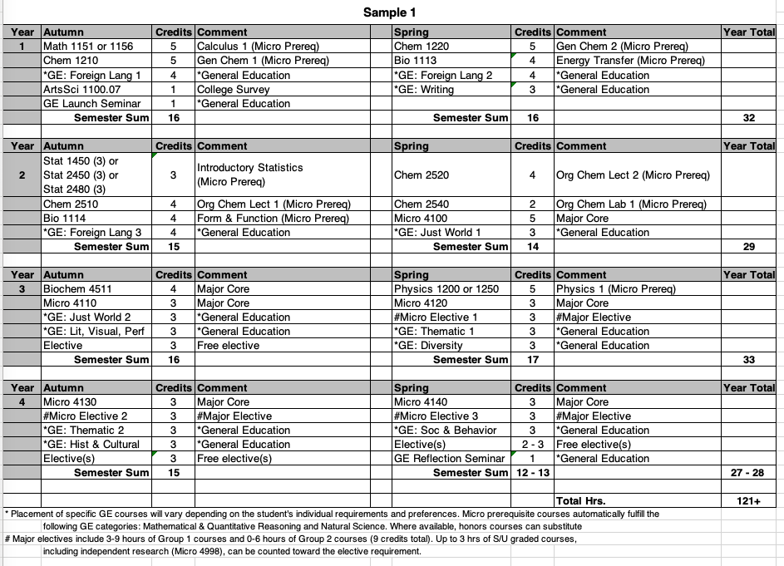

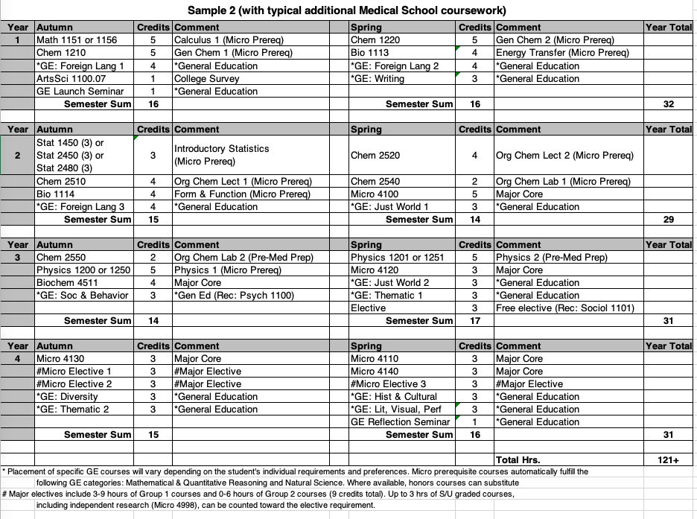
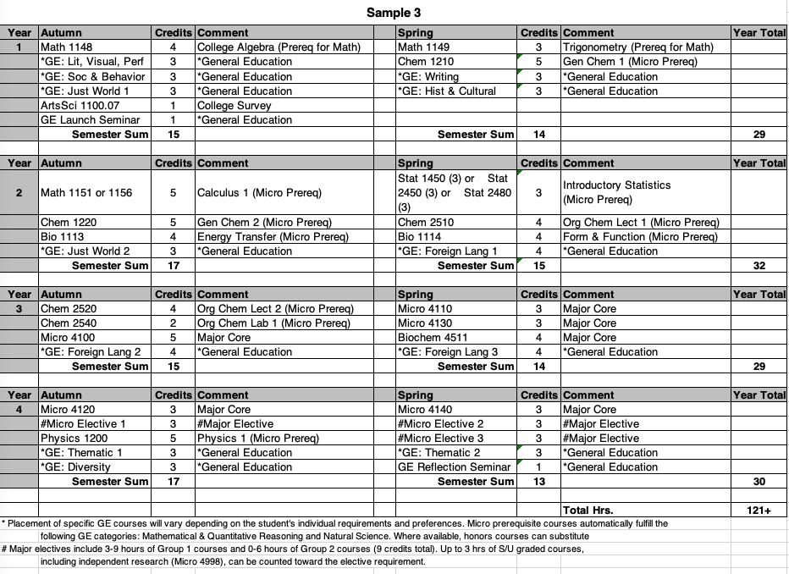

BS/MS in Microbiology
A combined BS/MS Degree in Microbiology is an opportunity for qualified undergraduates in Microbiology to begin the graduate program in Microbiology during their senior year, with the possibility of completing the Master's degree the following year. Students who are accepted into the Microbiology BS/MS Program are allowed to count 9 semester credit hours of classes toward both the undergraduate and graduate degrees. Applications to this program are accepted from October 1 – March 1. If you are interested in this dual degree program, please talk to the Microbiology advisor.
Eligibility
- Be a Rank 4 student (90 completed credits) in good academic standing (at least 3.5 GPA)
- Have completed MICRO4100†, MICRO 4120, and BIOCHEM4511
- Application to the Microbiology BS/MS program in spring semester of Junior Year
- Admission by the Microbiology Graduate Studies Committee and the OSU Graduate School

Sample Combined BS/MS Curriculum (Next page)
Year | Credits | Course (title) | GE/open | BS prereq. | BS core | BS elective | MS core | MS elective | MS S/U
1-AU | 15 | CHEM1210 (Gen Chem I) |  | 5
 |  | MATH1151 (Calc I) |  | 5
 |  | BIO1113 (Biology I) |  | 4
 |  | ASC1100.07 (Survey) | 1
1-SP | 15 | CHEM1220 (Gen Chem II) |  | 5
 |  | STATS1450 (Intro) |  | 3
 |  | BIO1114 (Biology II) |  | 4
 |  | GE Course | 3
2-AU | 16 | CHEM2510 (Org Chem I) |  | 4
 |  | PHYSICS1200 (Physics I) |  | 5
 |  | GE Courses | 7
2-SP | 15 | CHEM2520 (Org Chem II) |  | 4
 |  | CHEM2540 (Org Chem Lab I) |  | 2
 |  | Open or GE Course | 9
3-AU | 16 | BIOCHEM4511 (BioChem) |  |  | 4
 |  | MICRBIO4100 (General/Lab) |  |  | 5
 |  | GE course | 4
 |  | GE course | 3
3-SP | 15 | MICRBIO4110 (Path & Immuno) |  |  | 3
 |  | MICRBIO4120 (Microbial Physiology) |  |  | 3
 |  | GE or Open Elective(s) | 9
4-AU | 16 | MICRBIO4130 (Microbial Genetics) |  |  | 3
 |  | MICRBIO4140 (Molec Micro. Lab) |  |  | 3
 |  | MICRBIO6020 (Micro Phys & Biochem) |  |  |  | 3 | 3
 |  | MICRBIO7600 (First-year Orientation) |  |  |  |  |  |  | 1
 |  | GE course(s) | 6
4-SP | 16 | MICRBIO5161 (Intro. Comp. Genomics) |  |  |  | 3 | 3
 |  | MICRBIO6080 (Adv Microbial Genetics) |  |  |  | 3 | 3
 |  | MICRBIO7899 (Micro Colloquium) |  |  |  |  |  |  | 1
 |  | MICRBIO8899 (Seminars) |  |  |  |  |  |  | 1
 |  | GE or Open Elective(s) | 8
5-AU | 12 | MS elective |  |  |  |  |  | 3
 |  | MS elective |  |  |  |  |  | 3
 |  | MICRBIO6010 (Principles) |  |  |  |  | 2
 |  | MICRBIO7899 (Colloquium) |  |  |  |  |  |  | 1
 |  | MICRBIO8899 (Seminars) |  |  |  |  |  |  | 1
 |  | MICRBIO7193 (Research) or MICRBIO7999 |  |  |  |  |  |  | 2
5-SP | 10 | MS elective |  |  |  |  |  | 3
 |  | MS elective |  |  |  |  |  | 3
 |  | MICRBIO7899 (Colloquium) |  |  |  |  |  |  | 1
 |  | MICRBIO8899 (Seminars) |  |  |  |  |  |  | 1
 |  | (optional) MICRBIO7193 (Research) or MICRBIO7999 |  |  |  |  |  |  | 2
 |  | Total GE/open credits | 45
 |  | Total BS prerequisite credits |  | 46
 |  | Total BS core credits |  |  | 21
 |  | Total BS elective credits |  |  |  | 9
 |  | Total BS degree credits = 121
 |  | Total MS degree required credits |  |  |  |  | 11
 |  | Total MS degree elective credits |  |  |  |  |  | 12
 |  | Total MS degree S/U credits |  |  |  |  |  |  | 11
 |  | Total MS degree credits = 34

